Creative Brief
This brief concerns the Cool IT Challenge homepage intro animation only.
Some background: The Cool IT Challenge is Greenpeace's campaign to turn IT industry leaders into climate advocates and solution providers.

Read: http://www.thegreenitreview.com/2009/03/greenpeaces-green-it-challenge.html
Related: Greenpeace has been very successful to date with the Guide to Greener Electronics in mobilising interest/buzz among tech journalists, professionals, geeks and bloggers on IT websites (blogs, forums, tech news magazines). Electronics companies improve their e-waste/toxic chemicals practices as a result.

The difference: The Cool IT Challenge is about climate change stuff only (not chemicals), and so our target companies aren't only hardware manufacturers. We have also designed a game as part of the campaign website to encourage participation (above all, we want people to talk about targets and the campaign – increasing the pressure on the targets and recruiting more people to the cause).

Project Details
Project name: Cool IT Challenge homepage intro animation
Date: 23 April 2009
Campaign: Toxics/Climate
Commissioned by: Tom Dowdall
Project Lead: Eoin Dubsky <edubsky@greenpeace.org>
Deadline for delivery: 4 May

Project Overview
Flash animation to introduce Cool IT Challenge.
Greenpeace is ranking top IT CEOs against climate leadership criteria, and mobilising primarily a techy audience to pressure the CEOs to improve. Campaign goels until 2012. See campaign FAQ here: http://www.greenpeace.org/international/campaigns/climate-change/it-climate-leadership/about

For now there's no one-big-corporate-target in particular.

Objectives
To make climate leaders of the IT industry's leaders. The intro animation should address our primary audience (tech journalists, bloggers and enthusiasts/geeks). It should explain enough of the campaign to make website visitors want to participate.
Top reasons to participate are:
- It's a climate campaign for techies – not for politicos (e.g. petitions to European Commission about EU legislation), not for “everybody” (e.g. change your lightbulbs, turn off the lights, walk to work).
- IT companies can be moved by pressure from techies, bloggers and other ordinary people (e.g. Greenpeace's Guide to Greener Electronics successes)
- These CEOs have great climate leadership potential, if only they'd get off their arses
- It's a game where you can bet, play against others. (See explanation below)
- Climate change is important, and this year's UN meeting in Copenhagen is especially important to stop runaway climate change.

Game concept
The game is a way to encourage participation from people who might otherwise not participate in a climate campaign, and wouldn't agitate for a cause (e.g. leave a comment on a CEOs blog with a campaign demand).

DRAFT GAME RULES

1. Users must register and login to play. Email verification.

2. New players begin with a score of 0 points. The aim is to have
the highest score of player points. Highest scorers periodically rewarded
(overall, by country, by special task etc) with Greenpeace merchandise.

3. Players get 15 coins to bet before each time Greenpeace assesses
the CEOs.
4. Choosing from the list of 14 CEOs, players must bet on five

CEOs, ranking their favourites so one CEO gets 5 chips, another gets 4, another 3, then 2, then 1 (total = 15 chips).
5. Greenpeace publishes assessment results every 2 months, scoring the CEOs out of 100 for their climate leadership. Players can bet and change their bets for the 50 days after each assessment.

6. Players get points each assessment round if the CEOs that they
have bet on either:
1. Finish top of the CEO list
2. Greatest jump in rank (e.g. 10th place to 3rd place)
3. CEO makes the strongest speech for Copenhagen (judged by GP)
7. Points are awarded as follows:

Player's bet X CEO score

Example: If a player bet 5 chips on Sun Microsystems, and that
company comes out top of the list at 45 out of 100, and 1 chip
on Microsoft, which, say, jumps more places than any other with
30 points, then

5 X 45 = 225
1 X 30 = 30

225 + 30 = 255 new player points!
8. Players can also gain set points by recruiting friends,
spreading word, commenting, tagging, digging, favouriting etc,
value of rewards for action reflect the effort and impact of
user actions and most effective networkers, multiplyers etc etc.
Important: In the first version of the game we will only track friends recruited for points scoring. Every player has a referrer id which they share with friends to join in (thing http://websiteaddress?ref=eoindubsky). For every friend you recruit you get 5 points.
Greenpeace reward those who are good at playing the game and those that are good at taking action (that is possible to track), overall winners are ideally both.
The game engine needs to report "Top 5 players" stats in javascript for inclusion on the Planet2 webpages.

Audience Profile
Primary: IT professionals, geeks, tech bloggers and enthusiasts. English-speaking, international, more men than women. (More likely to play the game)
Secondary: Greenpeace supporters (More women than men, highly educated, climate change-aware and mindful of nature.) (More likely to want to learn more about the campaign first, maybe take action independently of the game)
Tertiary: The CEOs and IT executives themselves:
Google Eric Schmidt
Cisco John T. Chambers
IBM Samuel J. Palmisano
Intel Paul Otellini
Sun Microsystems Jonathan I. Schwartz
Microsoft Steve Ballmer
HP Mark Hurd
Dell Michael S. Dell
Fujitsu Kuniaki Nozoe
Sony Howard Stringer
Toshiba Atsutoshi Nishida
Sharp Katsuhiko Machida
Panasonic Fumio Ohtsubo
Nokia Olli-Pekka Kallasvuo

Tone/Personality
Tone: Dynamic, playful, action-oriented.

Technicalities
Files: SWF and original FLA flash files. Flash player 8 max.
Dimensions: maximum 560px X 300px. Ideally it should be resizable without breaking images.
Font family: Helvetica Neue and Verdana machine font.
Other colours and graphics to use: We have great illustrations of the CEOs – please use them, I'll send you Illustrator files of them on Fri or Mon. Here's a preview. It's a climate change campaign ultimately, so graphics, sounds or other elements to signify the planetary emergency would be good.

See homepage mockup below for an impression of where the intro will be:

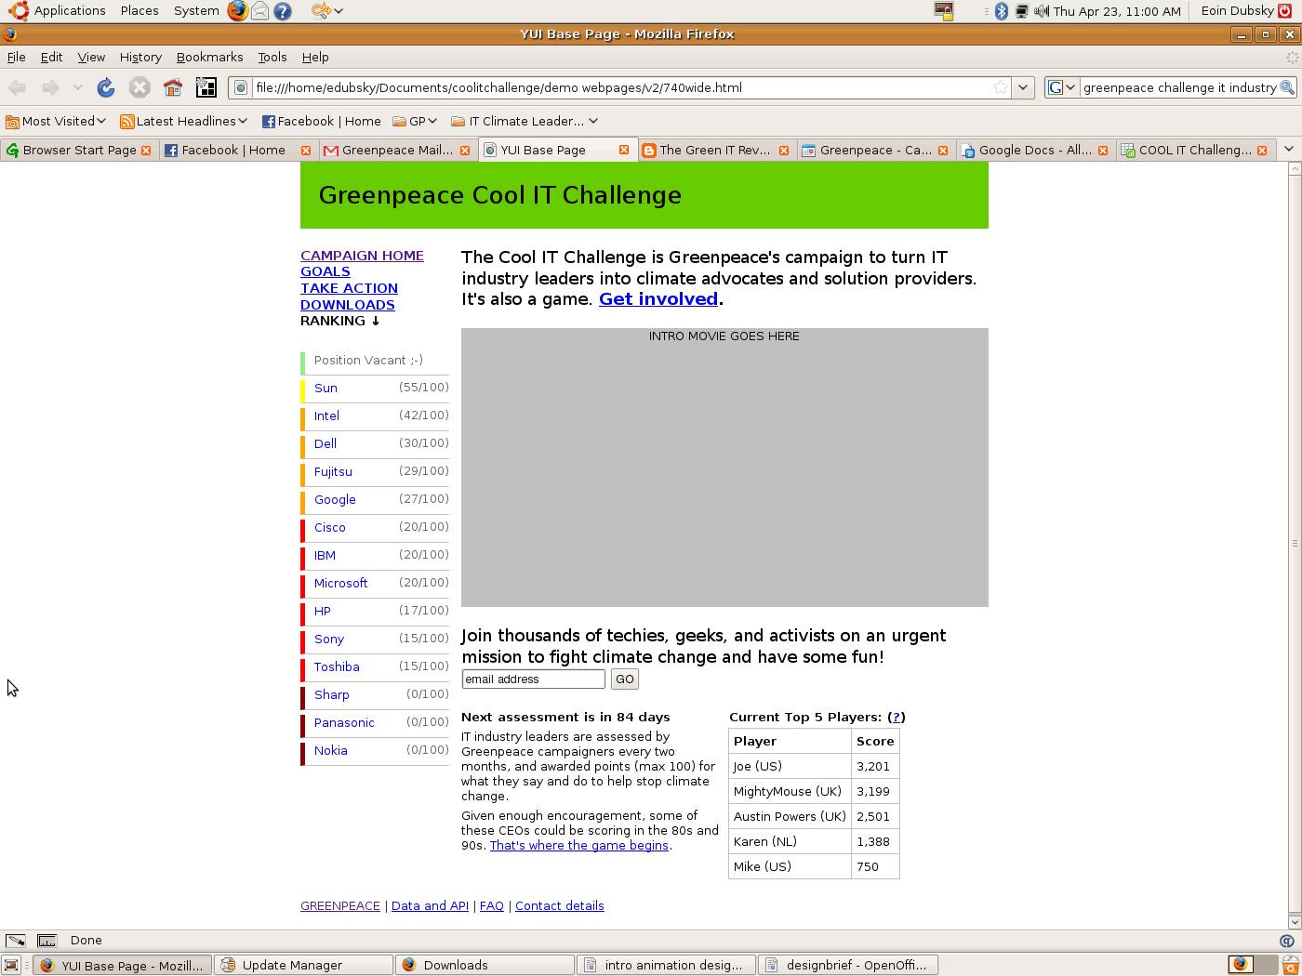
Text in the intro should be easy to edit or translate by Greenpeace (no need to be in XML file – but saved as text in flash, not graphics).

No voice-over, but sound would be great (especially something playful). Sound off button.

No autoplaying on load.

Endboard actions: At the end of the animation/intro people should be able to click to: Register to get involved and Read more about the campaign

Suggested Scripts
Note: Please see the links and read the text above for inspiration. You can use this suggested script or go your own way entirely.

1.
- Techies can save the planet
- Turning IT leaders into climate leaders can be fun too
- Agitate and they will react, it worked with Apple

2.
- 2% of global warming emissions come from the IT sector.
- Techies could do a lot to save the planet.
- Somebody needs to turn these IT leaders into climate advocates and solution providers.

